**Vanguard Initiative - New Growth through Smart Specialization**

**High Performance Production with 3D Printing**

***Mapping questionnaire***

***Da inviare compilato a:***

***info@aita3d.it***

**Section 1 – Actors profile**

**Please mark with an “X” the field which best fits your company/entity**

|  |  |
| --- | --- |
| **Service Bureaux**  (Companies offering 3DPrinting services) |  |
| **Original Equipment Manufacturers**  (companies designing, developing, building and selling Additive Manufacturing / 3D Printing Machines) |  |
| **3D Printing Materials Manufacturers**  (companies manufacturing materials to be processed by 3D Printing Technologies) |  |
| **3D Printing Software Developers**  (companies designing and developing software related to 3D Printing applications) |  |
| **Business Model Based on 3DPrinting**  (companies designing and manufacturing all their products by means of 3D Printing) |  |
| **Production companies**  (companies implementing 3DPrinting in the manufacturing of some of their products) |  |
| **AM / 3D Printing R+D Centers**  (Organizations doing AM / 3DPrinting research and development) |  |
| **Training & Technology Transfer Organizations**  **Entities doing training, technology transfer and consultancy in AM / 3D Printing.** |  |
| **Additive Manufacturing & 3D Printing Vendors**  (vendor representatives, selling, reparing and mantaining Additive Manufacturing / 3D Printing Systems) |  |
| **Fablabs & other related entities**  **doing social disemination and training on AM / 3DPrinting technologies** |  |
| **Additive manufacturing / 3D Printing Associations, Clusters and Regional Technology Platforms** |  |
| **Most representative industries using AM / 3DP in their product development and manufacturing processes** |  |

**Section 2 – Company/entity profile**

**Please insert your company/entity profile**

|  |  |
| --- | --- |
| **Company/Entity Name** |  |
| **Contact person** |  |
| **Web Site** |  |
| **Address** |  |
| **Phone** |  |
| **e-mail** |  |
| **Company/Entity size**  (choose from:  Large Enterpise (>250 employees)  Medium Sized (<250)  Small (<50)  Micro (<10) |  |
| **Organization**  (choose from: Profit, Non-Profit, Public Administration-Government) |  |

**Section 3 – Value chain position**

**Please, mark with an “X” the correct value chain position of your company/entity. You can choose even more than one field.**

|  |  |
| --- | --- |
| **Machines & Modification** |  |
| **Materials** |  |
| **Design for AM** |  |
| **Process** |  |
| **Post-process** |  |
| **ICT and Factory Integration** |  |
| **Leading Edge Application** |  |
| **Other**  (specify:_____________________) |  |

**Section 4 – Domain of application**

**Please, mark with an “X” the choices which best fit your company/entity**

|  |  |
| --- | --- |
| **Healthcare**  Implants, bridges, hearing aids, glasses, scanning, protheses, dentures, medical devices, intervention models, guides, templates, etc |  |
| **Aerospace**  Prototyping, complex low-volume (spare) parts, light weight components, engine components etc |  |
| **Automotive**  Prototyping, spare parts, personalized interior parts, complex low-volume (spare) parts etc |  |
| **Machinery & instruments**  Prototyping, complex low-volume (spare) parts, molds, models, manifolds etc |  |
| **Electronic & Elctr. Devices**  PCB’s, casing for electronics, integrated circuits, soalr panels, micro-devices etc |  |
| **Creative industries (lifestyle)**  Jewels, furniture, toys, art, lighting, decorative goods, etc |  |
| **Textiles**  Fashion, functional textiles |  |
| **Other**  specify:_____________________ |  |

**Section 5 – Technology**

**Please, mark with an “X” the choices which best fit your company/entity**

|  |  |
| --- | --- |
| **VAT Photopolymerisation** |  |
| **Materiall Jetting** |  |
| **Binder Jetting** |  |
| **Powder bed fusion** |  |
| **Material extrusion** |  |
| **Direct Energy Deposition** |  |
| **Sheet Lamitation** |  |
| **Other**  (specify:_____________________) |  |

**Section 6 – Materials**

**Please, mark with an “X” the choices which best fit your company/entity**

|  |  |
| --- | --- |
| **Polymer thermoset**  Epoxy resins, acrylate resin, ... |  |
| **Polymer Thermoplastic**  ABS, PA, PLA, PC, PMMA, PS, PEEK, Ultem, PPSF, ... |  |
| **Ferrous metals**  Maraging steel, Stainless steel, ... |  |
| **Non ferrous metals**  CoCr, Ti, Al, Inconel, ... |  |
| **Precious metals**  Gold, Silver, ... |  |
| **Industrial Ceramics**  Alumina, Zirconia, Silicon Nitride, ... |  |
| **Structural Ceramics**  Cement, Foundry sand |  |
| **Bio-materials**  Medical/in-body parts |  |
| **Food** |  |
| **Other**  specify:_____________________ |  |

**Section 7 – Existing Demonstration Infrastructure**

**Please, mark with an “X” the choices which best fit your company/entity**

|  |  |
| --- | --- |
| **Proof of concept** |  |
| **Prototype** |  |
| **Pilot Line** |  |
| **First Customers** |  |
| **Other**  specify:_____________________ |  |

**Section 8 – Demonstration Infrastructure**

**Is there any type of demonstrator existing in your region? If yes, can you list some key characteristics (publicly or privately owned, or co-ownership; 'open' to external users and foreign/international users)?**

**Tick the boxes (many choices per row and per column possible)**

|  |  |  |  |  |  |
| --- | --- | --- | --- | --- | --- |
|  | **Public** | **Private** | **Co-ownership** | **Open** | **International** |
| *1. No specific demonstration facilities, only standard teaching facilities at educational institutes* |  |  |  |  |  |
| *2. Demonstration facilities for training in state-of-the-art equipment* |  |  |  |  |  |
| *3. Fieldlab for (new) state-of-the-art equipment (TRL 7-9)* |  |  |  |  |  |
| *4. Environment with generation N+1 and N+2 equipment (TRL 5-8)* |  |  |  |  |  |

**At which TRL-level (see picture below) can demonstrators operate in your region for your priority application areas in the foreseeable future (2-3 years). Tick the relevant boxes with an “X” (many choices possible)**

|  |  |  |  |  |  |  |  |  |  |  |  |  |  |
| --- | --- | --- | --- | --- | --- | --- | --- | --- | --- | --- | --- | --- | --- |
|  |  | **1** | **2** | **3** | **4** | **5** | **6** | **7** | **8** | **9** | **10** | **11** | **12** |
| 1 | Healthcare |  |  |  |  |  |  |  |  |  |  |  |  |
| 2 | Aerospace |  |  |  |  |  |  |  |  |  |  |  |  |
| 3 | Automotive |  |  |  |  |  |  |  |  |  |  |  |  |
| 4 | Machinery/Instruments/Tooling |  |  |  |  |  |  |  |  |  |  |  |  |
| 5 | Electronic & Elctr. Devices |  |  |  |  |  |  |  |  |  |  |  |  |
| 6 | Creative industries |  |  |  |  |  |  |  |  |  |  |  |  |
| 7 | Textile |  |  |  |  |  |  |  |  |  |  |  |  |
| 8 | Other |  |  |  |  |  |  |  |  |  |  |  |  |

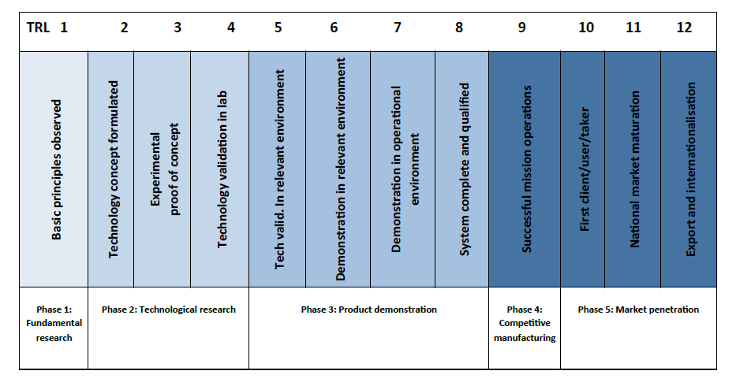

**Section 9 – Forward looking perspective of the region**

**What is the comparative position of the region with regard to 3-D Printing?**

**Mark with an “X” the sentence that describes the best your comparative position**

|  |  |
| --- | --- |
| The region has no significant industrial actor nor knowledge base in this domain |  |
| The region has no industrial activity in the field but it does have recognized research capacity in the domain |  |
| The region has some industrial activity but no substantial public research capacity |  |
| The region has both some industrial activities and established research capacities |  |
| The region's research capacity in this field is leading-edge internationally |  |
| Some of the region's industrial actors are world-class leaders in their domains of application |  |
| The region's research capacity is leading-edge, and its industrial actors are leaders in their domains of application |  |

**Can you list three recent participations of your region in EU research networks and projects within to 3-D printing? (100 words max per participation)**

|  |
| --- |
| **Participation 1** |
|  |
| **Participation 2** |
|  |
| **Participation 3** |
|  |

|  |
| --- |
| **Which actions does the regions foresee to take in the next two years with regard to 3-D printing? Which proposals for demonstration and piloting you would like to contribute to the Network? (open question, 100 words max)** |
|  |

**Where does the region want to stand with regard to 3-D printing five years from now?**

**Mark with an “X” the sentence that describes the best your expected position**

|  |  |
| --- | --- |
| To have developed some recognized research capacities in the field |  |
| To have attracted or developed some industrial activities in the region in this field |  |
| To be internationally recognized for its research excellence in some specific sub-fields |  |
| To be internationally recognized for its research excellence in many sub-fields |  |
| To become an international growth pole for new industrial applications, by attracting leading companies around world-class research centres |  |
| To play an leading role in developing applications, demonstrating their market potential and triggering effective market deployment |  |

**What is the expected benefit of "networked demonstration" for your region? (tick the box - many choices possible)**

|  |  |
| --- | --- |
| Better understanding of European market development (connected instead of isolated demonstrators) |  |
| Accelerating partner search in technology development, in market development |  |
| Learning through spill-overs, having access to other demonstrators and results of other demonstrations |  |
| Having a stronger European impact of the industry all together |  |
| Upgrading regional efforts at European scale |  |
| Acceleration of the development of new value chains and networks |  |
| Other |  |